Week 7

**2. Copy, move, and remove files using cp, mv, and rm commands.**

**Copy, Move, and Remove Files:**

* + **cp**: Copy files or directories.

cp source_file destination_file

* + **mv**: Move or rename files or directories.

mv source_file destination_file

* + **rm**: Remove files or directories.

rm file_name

1. **Create and delete directories using mkdir and rmdir.**

**Create and Delete Directories:**

* + **mkdir**: Create a new directory.

mkdir directory_name

* + **rmdir**: Remove an empty directory.

rmdir directory_name

4. **Change the current working directory using cd and display the present working directory using pwd.**

**Change and Display Current Working Directory:**

* + **cd**: Change the current working directory.

cd directory_path

* + **pwd**: Display the present working directory.

pwd

5. Consider two files that contain information about Employees and Departments in the following parameters: Employee (Name, EId, Salary, DID), Department (DID, DName, Location). Write a Python program to find the average salary of each department.

import csv

departments = {}

with open('Week-7/department.csv', mode='r') as file:

    reader = csv.reader(file)

    next(reader)  # Skip header

    for row in reader:

        DID, DName, DLocation = row

        departments[DID] = {'DName': DName, 'DLocation': DLocation, 'TotalSalary': 0, 'EmployeeCount': 0}

with open('Week-7/employees.csv', mode='r') as file:

    reader = csv.reader(file)

    next(reader)  # Skip header

    for row in reader:

        Name, EId, Salary, DID = row

        Salary = float(Salary)

        if DID in departments:

            departments[DID]['TotalSalary'] += Salary

            departments[DID]['EmployeeCount'] += 1

for DID, data in departments.items():

    if data['EmployeeCount'] > 0:

        average_salary = data['TotalSalary'] / data['EmployeeCount']

        print(f"Department: {data['DName']}, Location: {data['DLocation']}, Average Salary: {average_salary:.2f}")

    else:

        print(f"Department: {data['DName']}, Location: {data['DLocation']}, Average Salary: N/A")

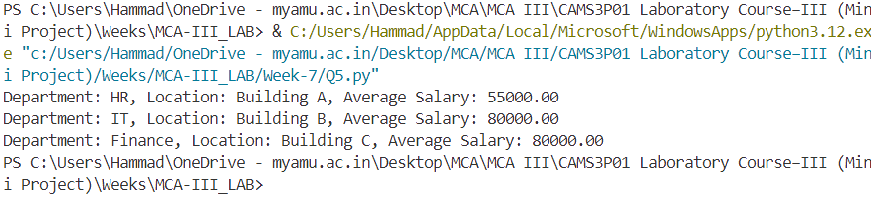

6. Consider two files having some lines of statements. Write a Python program to swap content present at middle line of first file with the content of last line of the second file. Note: First file contains odd numbers of lines of statement)

def read_file(file_path):

    with open(file_path, 'r') as file:

        lines = file.readlines()

    return lines

def write_file(file_path, lines):

    with open(file_path, 'w') as file:

        file.writelines(lines)

def swap_lines(file1, file2):

    lines1 = read_file(file1)

    lines2 = read_file(file2)

    middle_index = len(lines1) // 2

    last_index = len(lines2) - 1

    lines1[middle_index], lines2[last_index] = lines2[last_index], lines1[middle_index]

    write_file(file1, lines1)

    write_file(file2, lines2)

    print("Content swapped Successfully")

file1 = 'Week-7/file1.txt'

file2 = 'Week-7/file2.txt'

swap_lines(file1, file2)

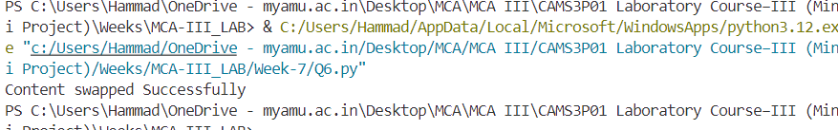

file1.txt

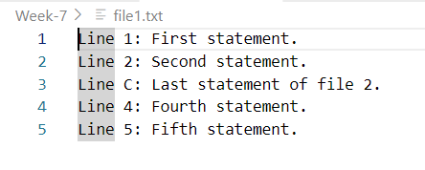

File2.txt

